## Stage 4: *Fasta Blasta*

|  |  |
| --- | --- |
| **Bay 4** | **Designer: Nick Stockwell**  **Rules: USPSA Competition Rules, Current Edition.** |

|  |  |
| --- | --- |
| **Scoring: Fixed Time / SE**  **Rnds/Pts: 24 / 120** | 12 IPSC paper targets, best 2 hits each, two strings. |

|  |  |
| --- | --- |
| **Procedurals & R.O. Notes** | Standard procedural penalties apply. Par time = 5.5 seconds for each string; 5.81 seconds = overtime |

|  |  |
| --- | --- |
| **Starting Position** | Standing facing downrange, with heels against marks on uprange fault line.  HANDGUN: Wrists below belt, handgun loaded and holstered  PCC: Loaded carbine held in both hands, buttstock touching belt, muzzle pointed downrange, safety on. |

|  |  |
| --- | --- |
| **Start Signal: Audible** | **Stop Signal: Last shot fired** |

|  |  |
| --- | --- |
| **STAGE PROCEDURE** | **STRING 1:** On audible start signal, engage targets in left OR right array with one round each as visible from within shooting area, perform a mandatory reload and engage targets in remaining array with one round each. Par time is 5.5 seconds.  **STRING 2:** On audible start signal, engage targets on opposite starting array from String 1 with one round each as visible from within shooting area, perform mandatory reload and engage targets on remaining array with one round each. Par time is 5.5 seconds.  **Notes:** See 1.2.2.1 for standard exercises (SE). |

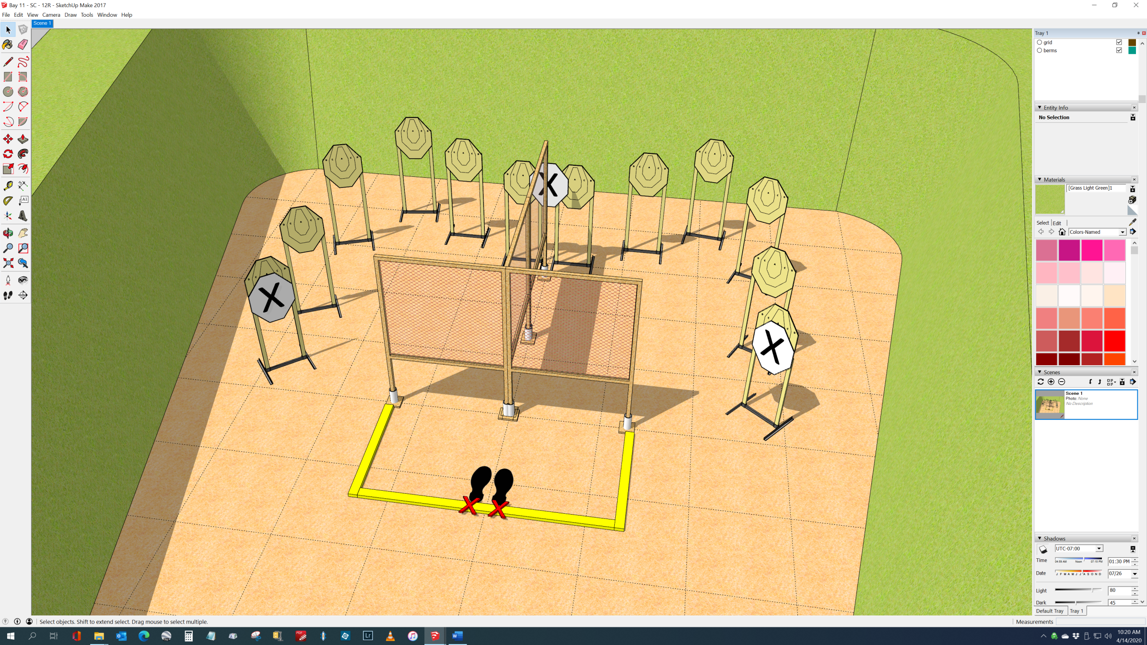

Right Array 🡪

🡨 Left Array